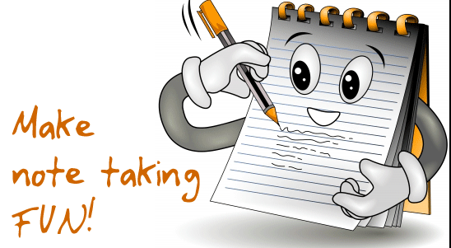

Three-Column Note-Taking System

Use 81/2-by-11-inch loose-leaf paper and write on just one side. Take the time to rule your page as follows:
- If the course is one in which lecture and text are closely related, use the 2-3-3-2 technique: Make columns of two inches down the left-hand side for recall clues, three inches in the middle for lecture notes and three inches on the right side for text notes. Leave a two-inch space across the bottom of the page for your own observations and conclusions.
- If it is a course where the lectures and the reading are not closely related, use separate pages for class notes and reading notes, following the 2-5-1 technique: Two inches at left for recall clues, five in the middle for lecture notes and an inch at the right for observations and conclusions. (After a while, you will not need to draw actual lines.)

The recall clue column is the key to higher marks.
- As soon as possible after you have written your notes, take the time to read them over - not studying them, just reading them.
- Check right away, while it is all still fresh, to see whether you have left out anything important or put down anything incorrectly, and make changes.
- After reviewing what you have written, set down recall clue words to the topics in your notes.
- These clue words should not repeat information but should designate or label the kind of information that is in your notes.

Using your notes, you can study for tests in the following manner:
- Take out your loose leaf pages and shift them around so the order makes the most sense for studying.
- Choose the first page and cover up the notes portion, leaving visible just the clues. See if you can recall the notes that go with the clues. As you get a page right, set it aside.
- If you are going to be taking a short-answer test, shuffle your note pages so that they are out of order. (That is why it is important to use just one side of the paper.) This approach provides for learning without the support of logical sequence, thus, closely approximating the actual pattern in which the information must be recalled.
- If you are going to be taking an essay test, you can safely predict that those areas on which the most notes are taken will most often be the areas on which essay questions will be based.

Take good notes and use them!

